**Problem Statement:**

You work for XYZ Corporation. Their application requires a database service that

can store data which can be retrieved if required. Implement a suitable service

for the same.

**While migrating, you are asked to perform the following**

**tasks:**

1. Create a DynamoDB table with partition key as ID.

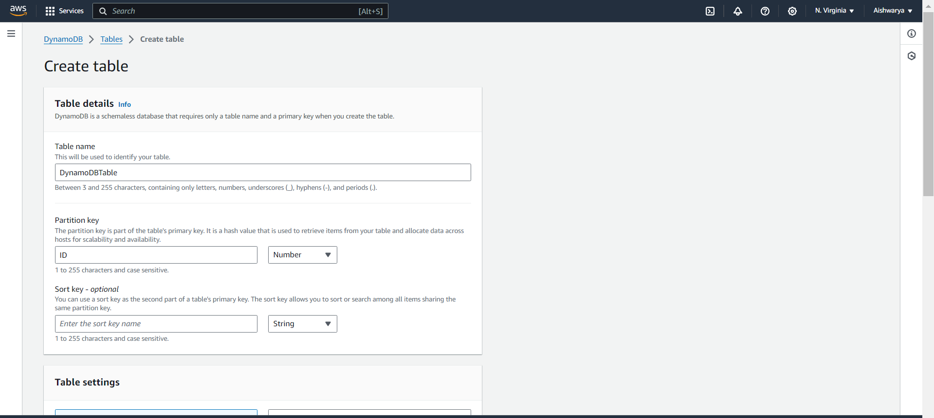

Choose default setting and create table

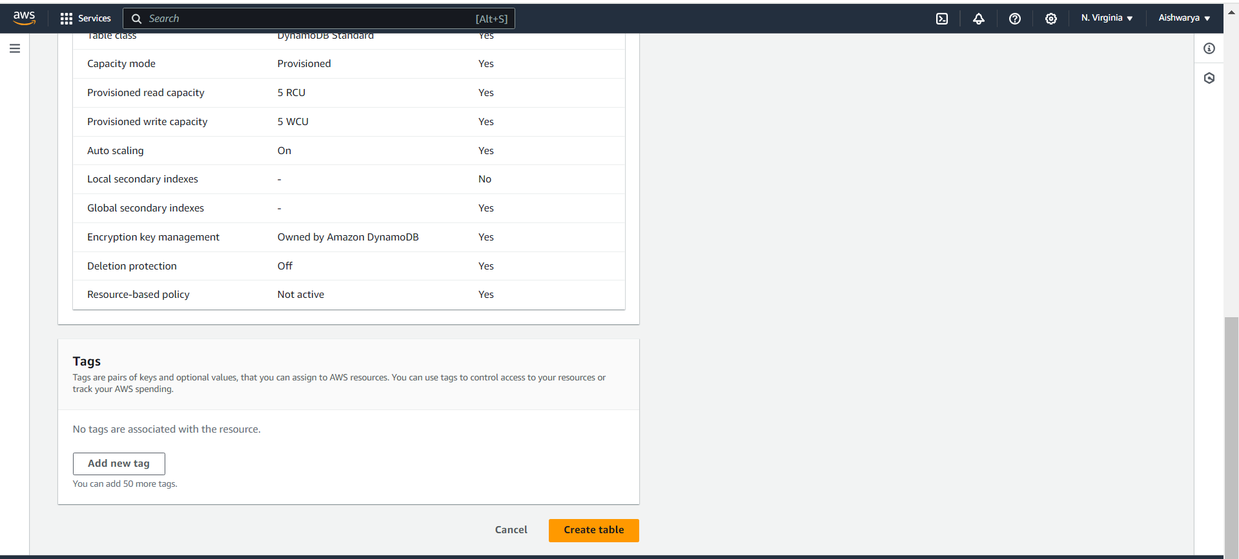

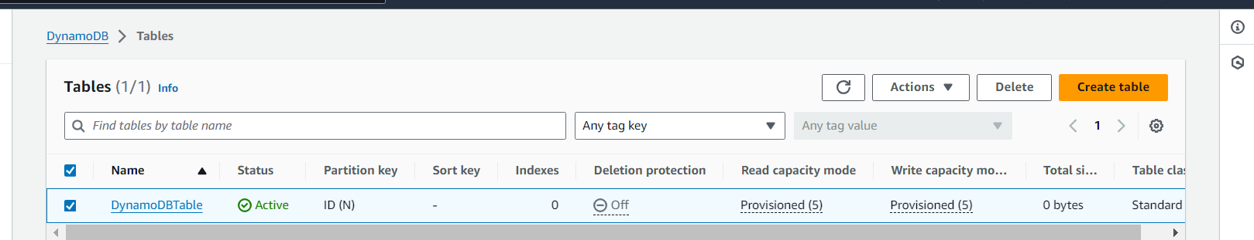

1. Add 5 items to the DynamoDB table.

To add an item go to Explore table items

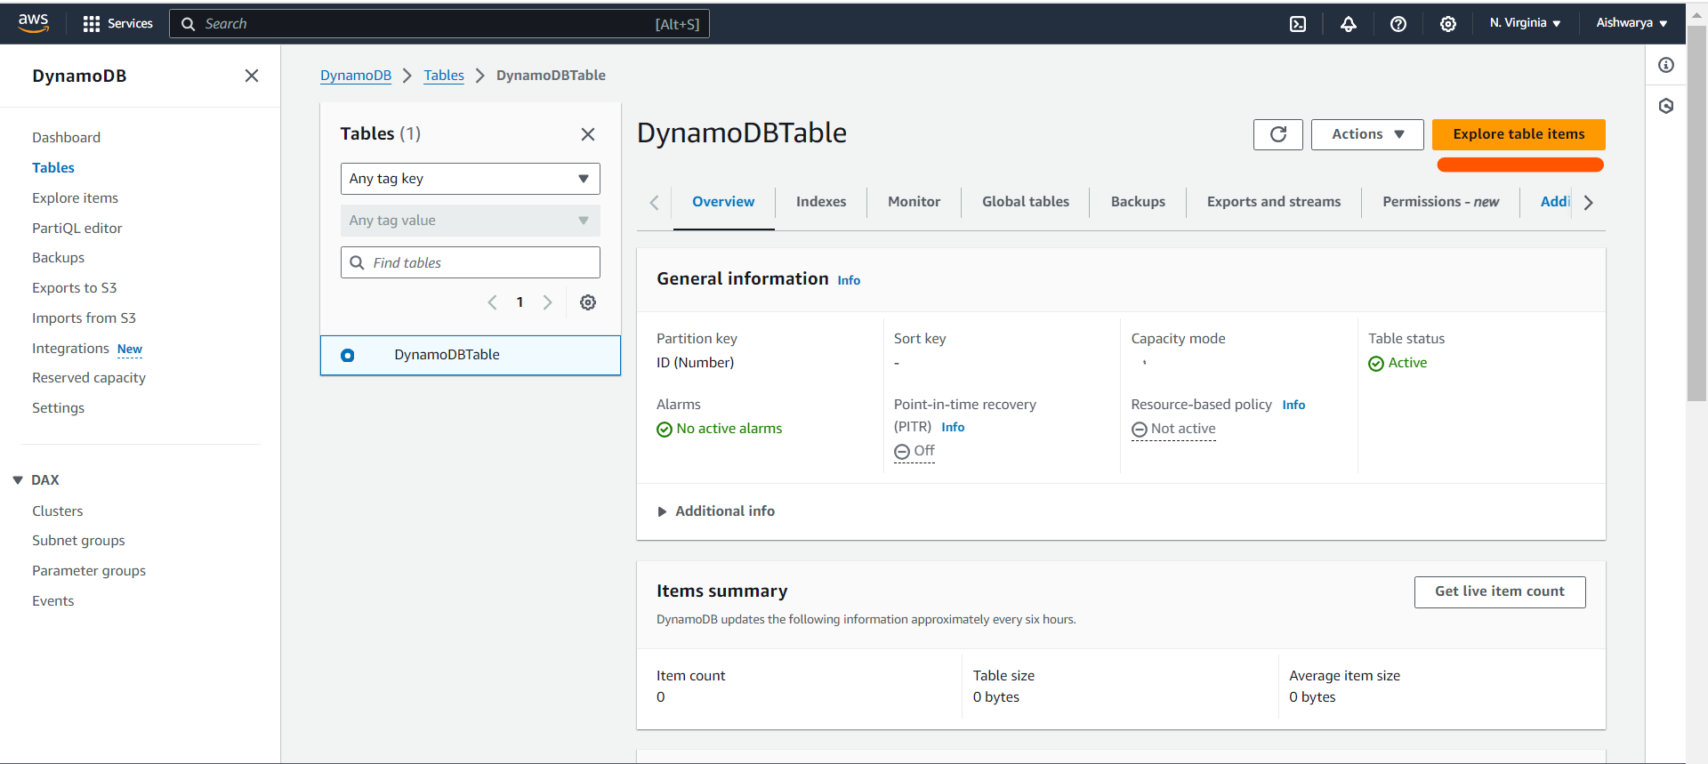

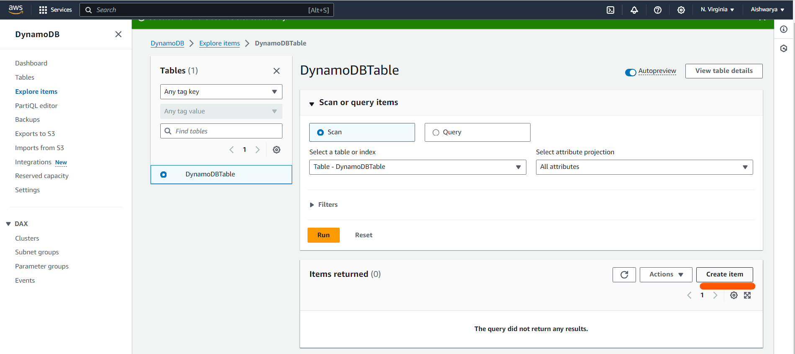

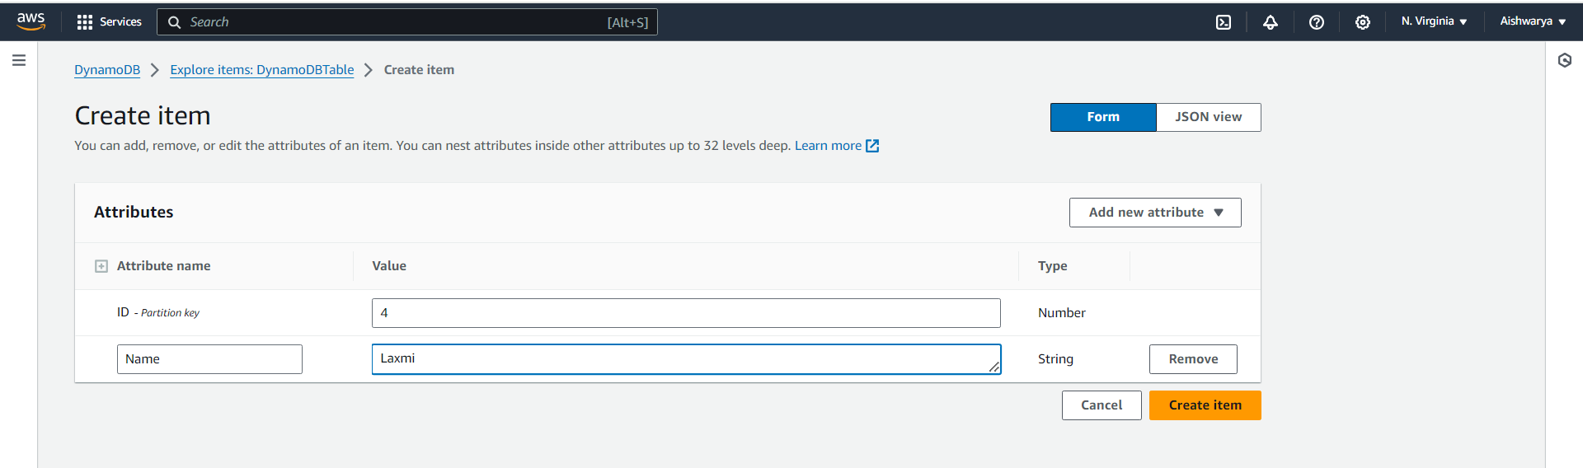

% items are added

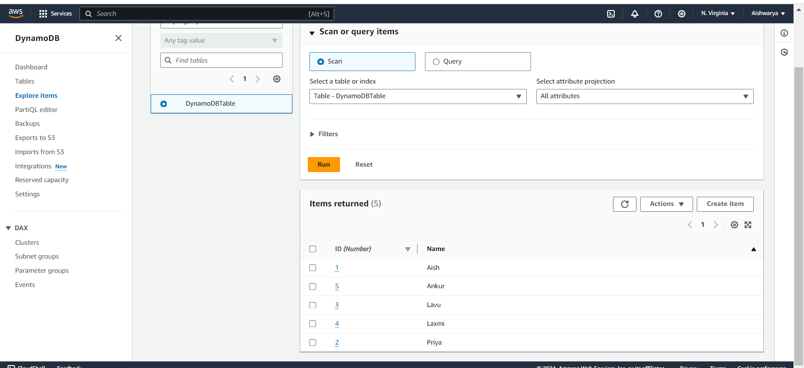

1. Take backup and delete the table.

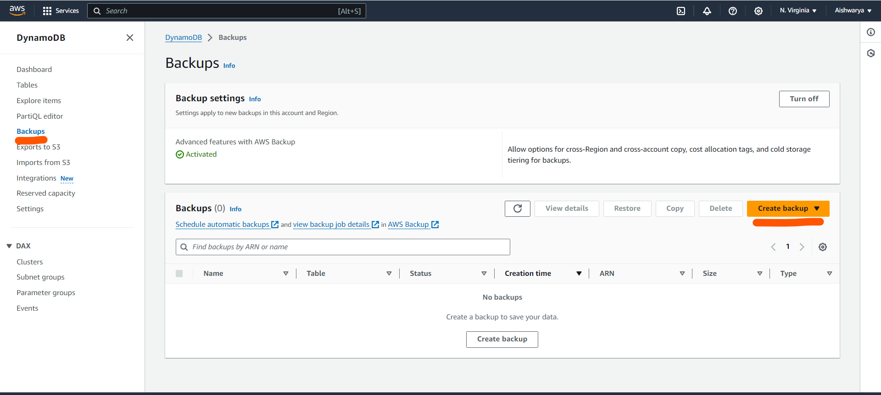

Select the table which we created above to take backup

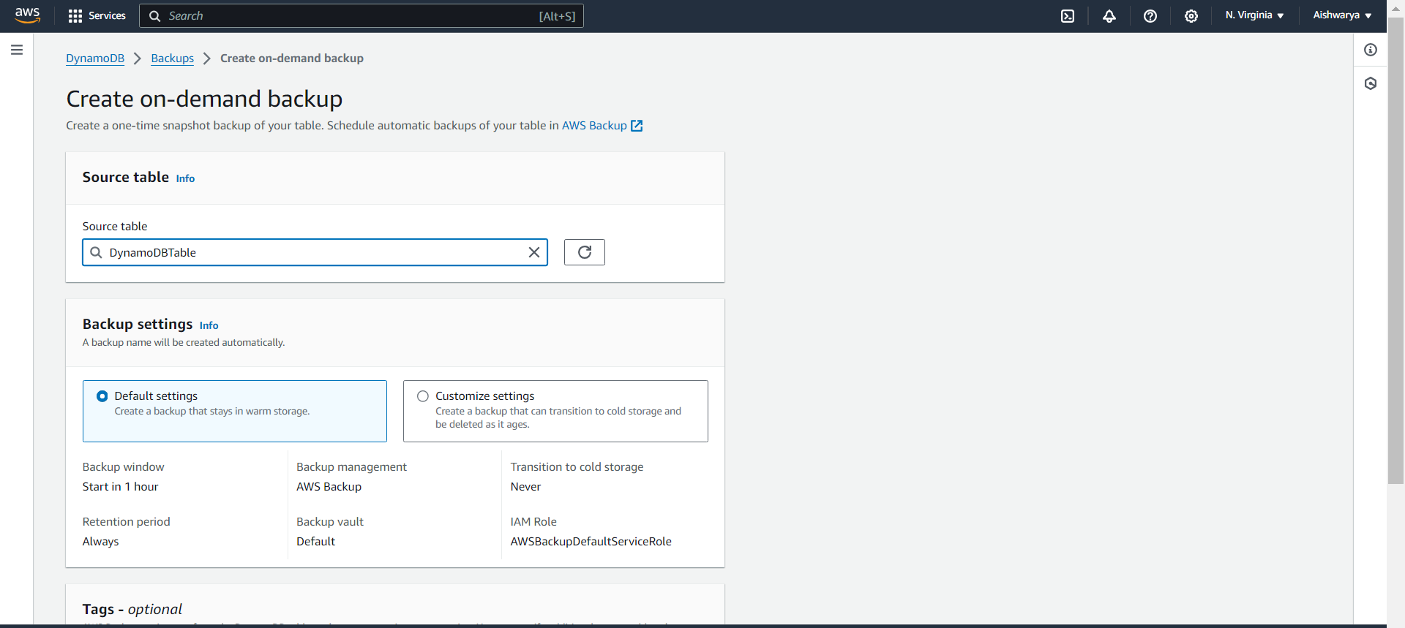

Backup job running

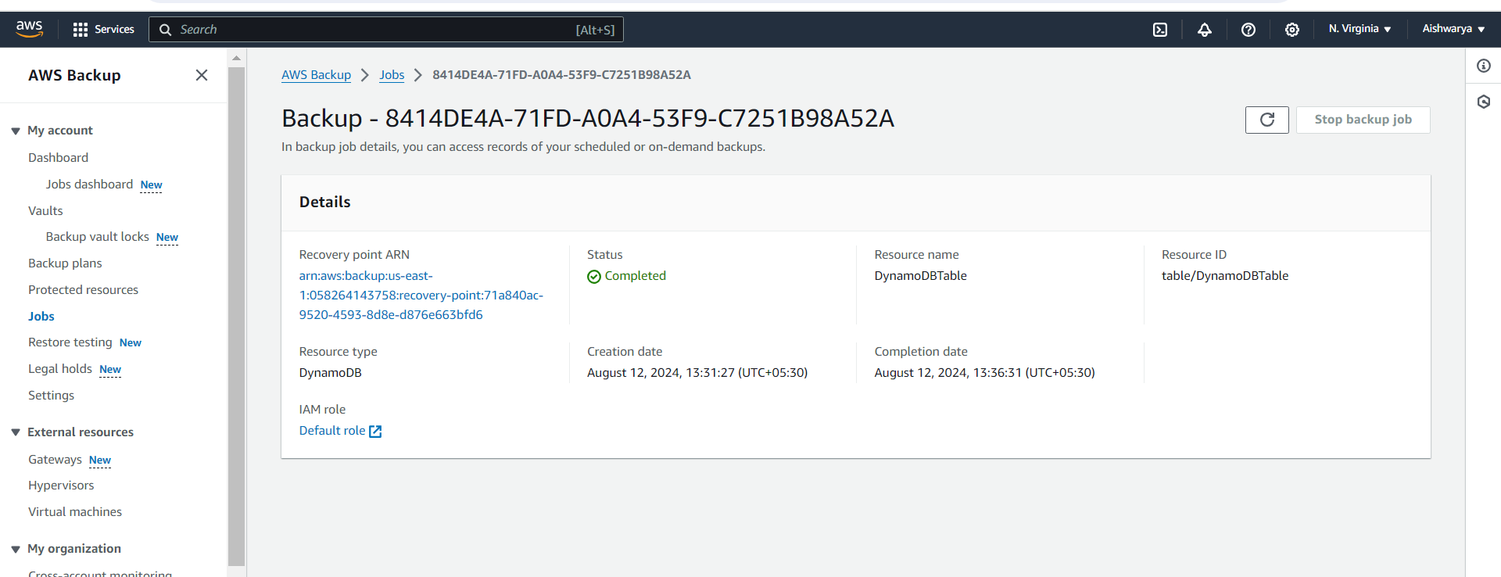

Created backup of table

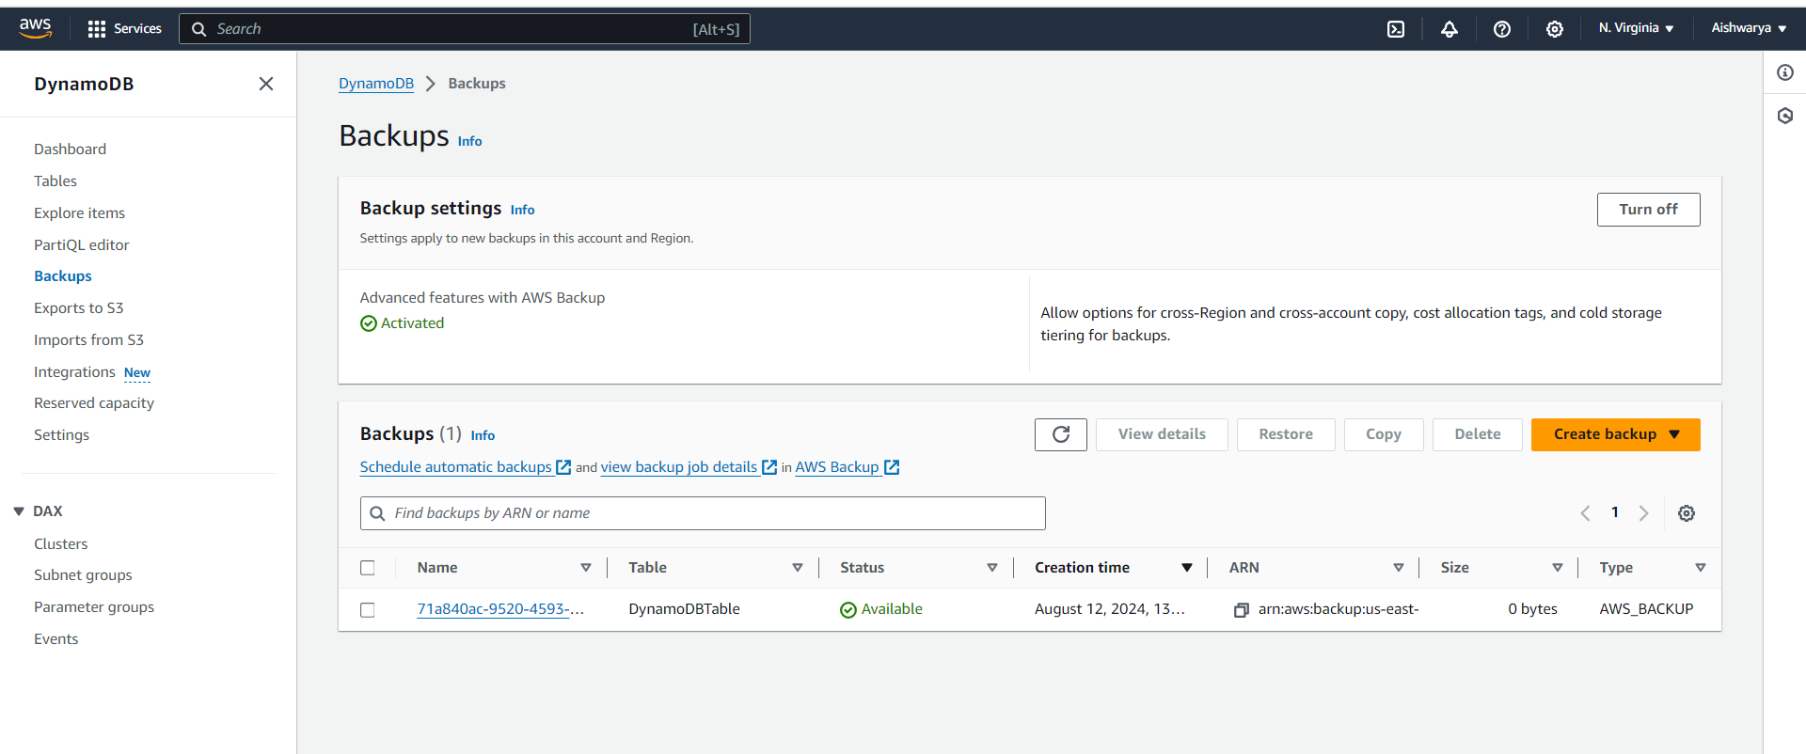

**Now delete the table**

